LESSON PLAN: Writing to a Pen Pal Abroad

Year 3-6, English KSSR
Year 5 Letters in Unit 1 page 5 and
Year 6 Unit 7 and 8 Letters
Prepared by: Camille Morrison
With input and classroom practice applied by:
Juliewati and Jurita in Asahan Cluster in Jasin
Resources provided by C.Morrison and textbook and internet
www.youthonline.ca/penpals

Objective:
Students do a pre-writing activity and learning about various countries, students will write a letter to a pen pal at a designated school and state in American in order to learn more about other students abroad.

Focus and Review:
Review with the students some of the conversations you can have with other students abroad.

Writing Topics:
- Your Name
- Your Age
- Where they live (city, state, country)
- Where you go to School
- What’s it like living where you are
- Holidays
- Your Hobbies
- Favorite Subject in School
- Pets
- Favorite TV Shows or Music
- Favorite Foods
- People in your Family (sisters, brothers, mother, father)
- Interesting things in your country
- Famous Places
- Hometown
- Weather
- Sister or brothers
- Historical things about their country
Write the topics on the board and have them brainstorm at least 6-8 to answer in complete sentences.

Objective:
The students will learn different historical things about United States of America to build up their conversation. For example: The President, holidays or famous places to see.
They will practice and produce multiple drafts and then edit them with a group or individually before providing the final draft. This will be guided with the teacher.
This activity will help to improve their reading, writing, and speaking skills. It will cover language arts, literary skills, geography, comprehension, social studies and self-confidence.

Picture Activity:
Divide the class into two sections, and separate the children. Show half of the class one section of a picture. Show the other half of the class the other section of the picture. Keep the children apart so that they cannot hear each other. Have each group discuss what they think the picture might be. Then have the groups join together and share what they think the whole picture is. Then show the full picture to the entire class.
- Was it helpful to hear other people’s ideas?
- Do you think you would have figured it out without the other group’s help?

Teacher Input:
Explain to the class that, right now, they only have half the picture about America.
Today they will write a letter to a student in America and will learn more about how their “pen pal” lives.
Show the students where America is on a world map and narrow it to a state in America. (Example, New York City, Florida, Washington D.C)
Explain where the location is on the map, if it is west, east, south or north of America?
What is famous about the state?
Explain to the students if they have similar climate, beaches, or food like Malaysia.

Guided Practice:
Review the proper format of a friendly letter with the students.
- Punctuation
- Grammar
- Capital Lettering
- Full Stops
- Spelling
- How to address an informal letter
- Appropriate Content
- Finding purpose and an audience in their writing.

With the students’ help, write a “skeleton” of a friendly letter on the board that they can use as a guide.
It should include:
- The heading (return address and date)
- The salutation
- The body
- The closing
- The signature

Independent Practice:
Pass out a sheet of writing paper to each student and tell them to begin.
Walk around the room and answer questions as needed.

Closure:
When the students have finished (or when the lesson is finished the children may need to finish their letters after the lesson is over), ask students to volunteer to share something that they wrote to their pen pals.
Explain to the students that we are going to mail these letters and it may take a while to get a response. (America is far away!)

Plans for Individual Differences:
- Visual students will benefit from literally “seeing” only half of a picture during the initial activity.
- Aural students will benefit from discussions and reviewing the parts of a friendly letter.
- Kinesthetic learners will benefit from actively writing a letter to someone who can explain what it is like to live in another country.

Evaluation:
Students will be evaluated on the format and the content of their letters.

EXAMPLES TEMPLATES:
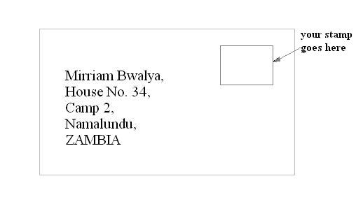

Introduction Letter:
Hi,<insert name of potential pen pal>!
My name is <insert your name> .
I read the information you left about yourself and I think we would make a great pen pal match.
Let me tell you a little bit about myself. I am <insert your age> years old and live in <insert country name>.
My hobbies include, <insert a short list of hobbies and/or interests>. I attend <insert public, private or home> school.
Something very interesting about me is <insert something unique about yourself>.
I hope to hear from you soon. You can reach me at <insert email address> and I will reply to you as soon as possible.

Your Pal,
<insert your name>

REPLY LETTER:
Hi, <insert name of person who wants to be your pen pal>

It was great hearing from you. I am very excited about being your pen pal. Let me tell you a little more about who I am.
I collect <insert what you collect>. I also like to listen to <insert a list of favorite bands>. In my spare time I like to <insert a short list of after-school interests>.
Tell me a little bit more about yourself.
What are you favorite things and what do you do in your spare time.
If your pen pal is from a different country, tell them what makes your country special. Be sure to ask them what they like most about the country they live in.
I'm looking forward to developing our pen pal relationship!

Your Pal,
<insert your name>

PICTURES:
